Table of Contents:
- An Introduction to Machine Learning
- Reinforcement Learning
- Introduction to Neural Networks
- Q-Learning
- Deep Q-Networks
- Implementation

- An Introduction to Machine Learning
Machine learning is a subset of artificial intelligence based on getting computers to learn mimic human-like learning. All machine learning has 3 basic principles: an algorithm is used to predict patterns and classify datasets, an error function evaluates the accuracy of that algorithm and then an optimisation process to make the model more fit the data more accurately.
Machine learning can be categorized into three main types: supervised learning, unsupervised learning and reinforcement learning.
In supervised learning, the system is provided with a dataset with correct the outputs provided for each input. The system will then learn from this data to be able to provide a correct output when a new and unknown input is provided. A simple example of an application of supervised learning is a system which can identify if an image is of a cat or dog after being shown 10,000 images of dogs and cats.
For unsupervised learning, the system must learn from an unlabelled dataset. It is used for categorising data into groups or clusters of data points with similar properties. This primarily has applications in creating predictive models, for example: how likely a customer is to buy a product based on previous purchasing behaviour.
The final form is reinforcement learning, the focus of this essay.
- What is Reinforcement Learning?
How would a human go around tackling a task such as beating a level of Space Invaders without any understanding of the rules apart from knowing the buttons to move left and right and the button to shoot? At first, they will move around randomly until they eventually get hit by a laser and have to restart. Through this experience they learn that getting hit has negative repercussions so will try to dodge lasers in the future. In the next game, they happen to hit an alien and see their score go up thus learn that shooting the aliens has a positive reward. Maybe they realise that if they are behind a shield they will not get hit and can delay the time until they receive get a negative reward from dying. Through this trial-and-error method, a human can very quickly learn strategies to any task. This is very similar to how a reinforcement learning agent would go completing a task too. It is for this reason why reinforcement learning is considered the most “human-like” machine learning technique.
To understand reinforcement learning it is important to get a grasp of some key concepts which I will refer to throughout this essay:
- Agent: The entity that makes the decisions on what actions to take. Its goal is to lean the best policy for maximizing the score it receives.
- Environment: The world which the agent lives in and interacts with. After each action it makes, the agent can take an observation of the effect this has on the environment to help decide what actions to make next.
- State: A description of the environment at a particular point in time.
- Reward: A scalar value provided to an agent based on its performance in completing certain goals within an environment. This can be positive or negative, but the agent’s primary goal is to maximise its cumulative reward, also known as its return.
- Value Function: The function used by the agent to estimate the cumulative reward of taking a specific action within a particular state or just being in a particular state. Essentially, a value function evaluates how beneficial it is for the agent to take a certain action or move into a certain state. These are the backbone or reinforcement learning and the Q-Function is the specific value function we will explore later in this essay.
- Policy: The general rules an agent will follow in a certain situation. It has an associated value function, and the goal of reinforcement learning is to find the optimal policy (the policy which has a predicated return greater than or equal to all other policies whilst being accurate enough to fulfil this return).
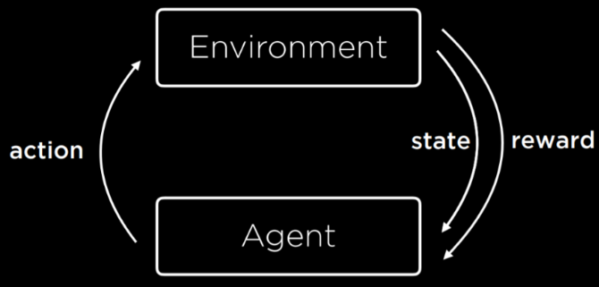
Reinforcement learning deals with decision-making problems. An agent updates its value function by interacting with an environment and receiving a reward. This process repeats and the value function will continue updating and improving until it is able to find the optimal action for any state it finds itself in.
The learning process involves the environment giving the agent a state and the agent performing an action. This triggers the environment to return an updated state and a reward, as shown in Fig. 1. The agent will use this to update its value function and, after many repetitions, enable it to take more optimal actions.
Fig. 1 A representation of how an agent will interact with its environment in order to update the value function.
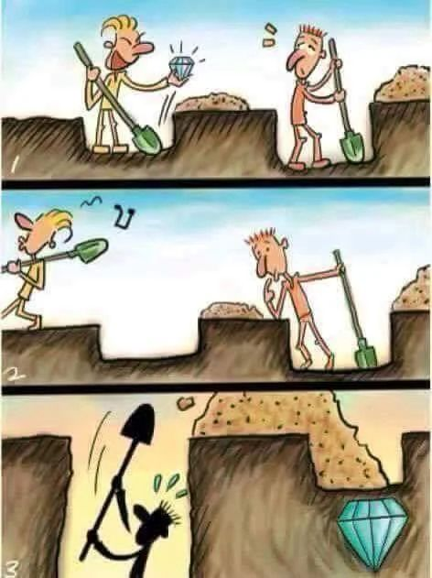
This leads us to one of the most prominent challenges with reinforcement learning, the Exploration-Exploitation dilemma. This is best represented in the cartoon in Fig. 2. After seeing someone else find a diamond taking a particular action (digging to the left), the character attempts to exploit this policy by continuing to dig to the left. Without exploring other actions (such as digging to the right), they are unable to find the much greater reward. If a healthy mix of both exploration and exploitation are not encouraged when designing a reinforcement learning program, the agent will be unable to learn an optimal policy for tackling a task. If exploitation is too high, the agent will repeatedly make the same actions to receive a short-term reward. However, if exploration is too high, the agent will act more randomly and will not pursue rewarding actions, also decreasing the long-term reward. Sticking to the idea that reinforcement learning is the most “human-like” machine learning technique, this is a lesson we have all learnt at some point - when we were probably told at a young age “you’ll never know until you try”. So, how can a program balance out exploration and exploitation optimally?
Fig. 2 A representation of how the exploration-exploitation dilemma can lead to an agent developing a sub-optimal policy.
The most popular strategy is called Epsilon Greedy. The basic principle is that a value epsilon, , is assigned a real number between 0 and 1. When making an action during learning, the agent will choose a random action (exploration) with probability ε and will act greedily and choose the most optimal action (exploitation) with probability . Exploration should be prioritised towards the beginning of learning when the agent has little knowledge on its environment. Once it has gained enough knowledge to know what actions increase its rewards, exploitation should be preferred to utilise these higher rewarding. This is often done by decaying over the agent’s life either exponentially or linearly. The nature of the decay is often problem-specific and requires experimentation.
When I attempted to implement my own reinforcement learning program, I came across a problem where my agent would find an optimal policy quickly (especially for the easier tasks) before had decayed very much. This would cause the agent to move away from the optimal policy it had already discovered as it was still prioritising exploration. To prevent this, I forced learning to end after achieving scores above a certain threshold multiple times. This is similar to another approach for epsilon decay called reward-based decay. This involves the value of epsilon decreasing by a fixed amount every time the agent has crossed some predetermined reward threshold. Although this will result in a more optimal policy, it will increase the time taken for learning to take place in more complicated problems.
- Introduction to Neural Networks
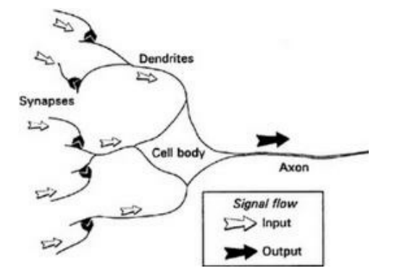
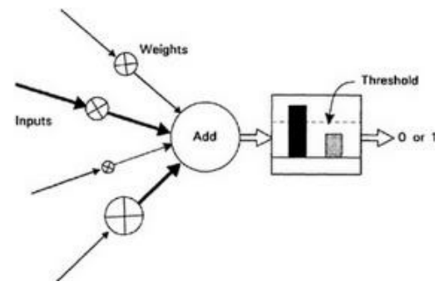
Before exploring Deep Q-Networks, it is necessary to understand the basics of neural networks. To start, we will compare artificial neural networks with biological neural networks. The human brain contains roughly 86 billion neurons (a basic version of which is shown in Fig. 3). Neurons communicate via signals made up of short spikes in voltage passing through their cell membranes. These signals pass between neurons through electrochemical junctions called synapses. Each neuron will receive signals from thousands of connections and combines them in some way to decide if it will also fire a signal. Whether a signal is fired or not will depend on how strong the synaptic connection is between other neurons but also whether the neuron is excitatory (promoting of impulse generation) or inhibitory (preventing of impulse generation). This is very similar to the concept of artificial neural networks.
Fig. 3 A comparison between the structure of a biological neuron found in the brain and an artificial neuron
So how does an artificial neuron work? In essence, it is a mathematical formula which takes in several numbers as inputs and based on their linear combination, it decides on an output – very similar to a biological neuron. Each connection with a previous neuron (the equivalent of a synapse) will have a weight attached. These weights could be compared with the strength of the synaptic connection between neurons. Linear combination is the sum of the products of the inputs and their assigned weights – as shown in the formula below. A bias is also included to shift the output, allowing the model to fit the data better (this can be compared with the term in a linear equation).

Where:
- is the output of the linear combination
- are the inputs for previous neurons (where ranges from 0 to , the number of inputs)
- are the weights assinged to each input
- is bias
The next step is to pass the result of the linear combination through an activation function to produce an output between 0 and 1 inclusive. There are multiple of these to choose from as shown in Fig. 4. The function shown in the artificial neuron in Fig. 3 is a simple step function. This will give an output of 0 unless a certain threshold is met:

Where:
- is the output of the linear combination
- is the threshold value
Unlike with biological neurons which can only release a signal or not, artificial neurons are able to give any real number between 0 and 1 as an output. This works as almost as a scale expressing confidence in the function’s judgement. The main way for achieving these outputs is with the non-linear sigmoid function:

The sigmoid function was made great use of from the mid-1980’s however it was not the perfect solution. The ideal function would look and act linear due to the vanishing gradient problem. This occurs during learning since the function must be continuously integrated so will become infinitely small, hindering the training. On the other hand, as we saw earlier with the step function, a non-linear function would be able to handle problems with much greater complexity. The rather simple solution to these problems is still considered one of the greatest breakthroughs in neural networking.
The Rectified Linear Activation Unit (ReLU) Function is a piecewise function which will return zero if the input is negative or equal to zero but will return the input if not:

Apart from its linear nature above zero, the fact that the ReLU function is capable of returning zero itself (unlike the sigmoid function which could only return numbers close to zero) is called Sparse Representation and improved efficiency during learning. On top of that, the ReLU function is easy to implement and much less computationally expensive than computing the exponential function which is required in the sigmoid activation.
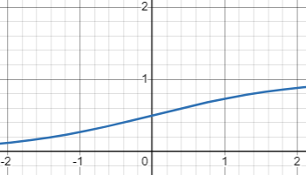
Fig. 4 Graphs showing the step, sigmoid and ReLU functions.

These neurons (also called nodes) are the building blocks of neural network structures. Each neural network will consist of three sections - see Fig. 5: the input layer, hidden layers and output layer. The input layer has one node for each numerical input variable. The output layer produces the final predictions and is made up of one node for each possible classification. For example, a neural network took a simple 64x64 pixel image as an input and had to predict whether it was of a cat, dog or bird. It might have 4096 nodes in its input layer (one for each pixel), taking the colour value of each pixel as input. The output layer will have three neurons, one for each potential category of classification (i.e. one for dog, cat and bird). The output values at each of these neurons will be the probability that the image is of said classification so will add up to 1. The neural network will output the classification with the highest probability as its prediction.
Fig. 5 An example of the structure of a neural network.
In between these two layers are the hidden layers where most of the processing takes place. Both the number of hidden layers and the number of neurons within each layer can vary and experimentation is often needed to work out how many are needed. In general, more complex problems will require more layers and neurons or the neural network will struggle to learn the underlying patterns to the data. However, too many layers or neurons also comes with its downsides. Mainly, making the network too powerful can lead to overfitting. This is when the network learns the data rather than the underlying patterns in the data. Most data sets will contain useful data which show trends but also irrelevant information, called noise. We want the network to lean the trends and discard the noise. Overfitting will cause network to struggle during implementation as it will not be able to handle new situations. Too many layers or neurons will also increase the time needed for computation so the aim should be to have as few as possible with the network still working to a strong standard.
When the neural network is training, all weights and biases start off random. The general idea is to pass the data through the network, calculate the error in the outputted values and then readjust the weights and biases. This starts with the forward pass where data is passed through the network. The outputted values will then be passed through a loss function which compares the outputs to the expected outputs. This function will vary by task but will most commonly be the mean squared error (MSE) function. MSE finds the average of the squared differences between the target and the predicted error.

Where:
- is the size of the data set used
- is the desired ouput from the neural network
- is the acutal output
The main positive of the MSE function is that, since it is squared, it will handle predicted values both below and above the expected but still punishes a greater error. However, one disadvantage of this loss function is that it is heavily sensitive to outliers. A predicted value much higher or lower than the expected will increase the loss significantly.
This is followed by backpropagation, the process of the network learning from its mistakes and updating the weights and biases to minimize the loss. This is often done using the iterative gradient descent algorithm which aims to find the global minima of the loss function. A good way of visualising this algorithm is by imagining the loss function as hilly landscape, as shown in Fig. 6. The goal is to find the global minimum of the hills by continuously taking steps to down the steepest gradient until finding a minima. Since many functions will have local minima, the hyperparameters of the algorithm need to be fine-tuned to skip over these. The formula for gradient descent is shown below:
Fig. 6 A visualisation of gradient descent

Where:
- is the weight at a specific neuron
- is the value obtained from the loss function
- is the learning rate
The learning rate is the hyperparameter used to avoid getting stuck in a local minimum. Since finding the derivative can be thought of as taking an infinite number of small steps down the gradient, this would take too long for our program to calculate. This is why the derivative is multiplied by the learning rate. The learning rate can be thought of as the size of the steps we are taking down the hill. The use of a learning rate is also very useful as it helps improve the efficiency of the algorithm. As shown in Fig. 7, a more precise learning rate can lead to the algorithm finding the minimum faster. A learning rate too low will be too computationally expensive whilst a learning rate too high may cause a jump over the minimum point. The value of the learning rate is often found through experimentation.
Fig. 7 Graphs showing the effect of the learning rate on an algorithm finding the minimum

Another way of improving gradient descent is by varying the is by varying the type of algorithm we use. The version described above is batch gradient descent. This is a very stable method but will have a slower convergence when working with larger datasets or data with more noise. Another variation is stochastic gradient descent (SGD). This works by selecting a random sample to pass through the network before backpropagation rather than the whole dataset. This deals with the inefficiency of standard gradient descent however may struggle to actually find the minimum when working with noisier data. The difference between these variations in our hills analogy could be seen as shuffling down the hill slowly to find the route which always sticks to the steepest gradient and taking larger steps to a part which looks somewhat downwards. Both versions have their strengths and weaknesses, so the most common solution is mini-batch gradient descent. This involves passing a small batch of the data through the network at one time before backpropagation. This reduces the effect of noise whilst keeping the algorithm computationally efficient.
Training takes place by repeating forward pass, loss calculation and backpropagation. After a certain number of repeats, a validation set of more data is passed through. When the accuracy of the network for said set stops increasing, training stops to prevent overfitting. If the accuracy tapers off before reaching the expected accuracy level, the neural network will probably need finetuning.
Deep neural networks are essentially neural networks with many hidden layers. This allows the network to learn trends in more complex datasets. Deep learning has many applications in AI, including image recognition, natural language processing and – of course – reinforcement learning.
- Q-Learning
Q-Learning is a reinforcement learning algorithm which aims to learn the optimal policy for selecting an action given a specific state. It does so by calculating a Q-value for each specific state-action pair using the Q-function. This Q-value is an estimate of the cumulative reward for taking the action in the current state and then following the current policy in further states.
The basis for Q-learning comes from the Bellman equation which calculates the value of being in a given state:

Where:
- is the value of a given state
- is the reward received for taking action is state
- is the state the agent is in after taking in
- is the discount rate
V = 0.43 | V = 0.39 |  | V = 0.9 | *END*  V = 1
V = 0.48 |  |  | V = 0.81
V = 0.53 | V = 0.60 | V = 0.66 | V = 0.73 | V = 0.66
V = 0.48 |  |  |  | V = 0.60
*START*  V = 0.43 | V = 0.39 | V = 0.43 | V = 0.48 | V = 0.53
The equation essentially iterates over every possible action within a state and calculates the reward for taking said action, returning the reward received from taking the action which maximised the future reward. To do this it recursively calls itself to find the value for all other states within an environment. After learning the values of all states, it will implement its knowledge by continuously moving to the state with the greatest value.
Fig. 9 An example of how an agent would use the Bellman’s equation to value each state in a simple maze and the path it would follow (light green) to find the exit (dark green)
The discount rate is a value between 0 and 1 (usually from 0.9 to 0.99). If = 0.9, then only 90% of is included in . For example, imagine we had an agent that was using the Bellman equation with = 1 to navigate through a simple maze where it received a reward of +1 for completion. This agent would calculate a value for the state next to the exit to be +1 since the maximum reward for this state given all possible actions is +0 and the value of the state the agent will end up in from taking this action (the exit) is +1. This same calculation will be repeated for all states in the environment meaning all states and with a value of +1. This is of no use to the agent when it is deployed into the environment since it will end up randomly moving around with no way of determining which direction the exit is in. By lowering the discount rate, the value of each state will decrease further from the exit meaning the agent can easily follow the path of increasing state values (see Fig. 9).
Using the Bellman equation works extremely well in more simple environments such as the maze in Fig. 9. However, as the number of possible states increases, it starts to become very computationally expensive to iterate through every single state to calculate their values. Also, the Bellman equation assumes a constant environment like the maze. However, if moving enemies were to be introduced to the maze, the values from the Bellman equation no longer stand true and need updating. This is where temporal difference comes in use.
Temporal difference is an adjustment to Q-learning where, instead of finding the value of a particular state, the values of state-action pairs are found. Temporal difference (or TD) is the difference between the estimated Q-value before an action is made and then the actual Q-value after the action has been made. This could be expressed as where the equation for the experienced Q-value is as derived from the Bellman equation. Temporal difference can be seen as updating a Q-value from an estimate to slightly less of an estimate (the next actual received award plus the estimated Q-value of the next state-action pair). Q-values are initially set to 0 and the agent explores the environment, updating these Q-values using the TD-update equation:

Where:
- is the current state
- is the action performed in the state
- is the reward received for taking action in state
- is the state the agent would be in after performing action
- is the action the agent would take in if it was following its current policy
- is the discount factor
- is the learning rate
TD is much more important in a changing environment where states may only give punishments at certain times (for example, in a game when an enemy happens to be in a position). It seems logical to just replace the predicted Q-value with the experienced Q-value since that is what actually happened. However, in a constantly changing environment, the temporal difference will never be 0 (ie: the predicted Q-value will never be correct) and is often large. So, replacing the Q-value will cause little consistency in how the agent acts which inhibits learning trends (such as how the enemies move). This is why the learning rate is used. This is usually a value close to 0 (0.05 is commonly used) and is multiplied by the experienced Q-value to reduce the affect the experience has on the agent’s policy.
The main difference between the Bellman equation and Q-learning is how the agent learns. In the Bellman equation, the agent will calculate the values of all states immediately to work out the optimal policy before acting itself. In Q-learning, the agent learns by exploring the environment and updating the state-action pairs as it goes. Since Q-learning requires exploration, an epsilon greedy strategy is often used to aid this.
So, Q-learning is clearly an upgrade on the Bellman equation due to its ability to learn much more complex environments, however, it is still not good enough in some cases. In environments with a near-infinite number of states within its environment (such as an Atari game or a self-driving car on roads), it becomes impossible to find the Q-value for every state-action pair. This is where Q-learning and neural networks meet.
- Deep Q-Networks
A Deep Q-Network (DQN) is an algorithm which combines both Q-learning and neural networks. It addresses the limitations of Q-learning by using a deep neural network to approximate the Q-values of each action in a given state. This means that rather than storing each Q-value (which would be very impractical in large environments) it calculates each state-action value when it appears.
The structure of a DQN is very similar to the structure of a standard deep neural network but is more specialised. In the input layer, the number of nodes is equal to the number of inputs from the environment. For example, in an Atari game, the network may consist of an input node for each pixel of the game. The output layer is made up of nodes representing all the possible actions in a state. The neural network will output a value in each of these nodes which will represent the Q-value of said action (these values will sum to 1). The action with the highest Q-value is the one that the agent will take.
The process of training a DQN differs slightly from training standard neural networks and Q-learning agents. The network will begin with random weights and biases and the agent will begin exploring its environment. As it explores, as in Q-learning, the agent will use temporal difference and predict a Q-value for a state-action pair and then compare this to the actual Q-value (the reward received from taking the action plus the discounted expected Q-value of the next optimal state-action pair). In practice, this involves summing the reward received and the highest value that the DQN spits out for the next state. The network will then go through the standard process of backpropagation using a loss function and adjusting the weights. However, the problem with this method is that the Q-value the network gives for the next state (which is assumed as the “actual” Q-value) may not be a correct. This would then cause the network to readjust itself to fit an incorrect policy. Since Q-learning encourages picking actions with higher Q-values, the agent DQN will start overestimating all values. To combat this, Double Deep Q-learning is used. This involves having two deep neural networks: the normal policy network and the target network. The target network will be used to produce the Q-values used in temporal difference and the policy network will be updated to try and fit the target network. While the policy network updates after every action, the target network will only update to the same weights and biases as the policy network after a certain number of actions. This will stop the network from trying to train onto itself, reducing any overestimations.
Another aspect of DQN which differs from normal neural networking is experience replay. Imagine we are training a self-driving car using a DQN. Most of the states the car will be in are empty roads which only require simple actions like acceleration or slight readjustments in steering. There will be much fewer states which involve more complicated situations such as congestion or pedestrians. If the agent trains itself using every single action it will become very good at some situations and have little experience with edge cases (states which do not appear often and differ drastically from standard states). As well as this, using every state to update the network will be very computationally expensive. To prevent this, during exploration the agent will store each experience (a tuple made up of the initial state, action taken, reward received and ending state) in a data structure called the replay memory. After a fixed interval of actions taken, the agent will then randomly sample some experiences (the number of these is known as the batch size) from the replay memory and update the DQN. This will help the agent learn to handle all situations and not just the most common ones.
There are many aspects to DQN so below is the basic algorithm as to how they work:
- Initialisation: two neural networks are set up with the same random weights and biases, these are the policy network and target network. An empty list is created to act as the experience replay. There are also lots of defined hyperparameters (such as the learning rate and batch size)
- The agent starts interacting with the environment. It will start off taking random actions but towards the end will be more likely to take intentional actions. When taking an intentional action, it will input the state into the neural network and choose the action with the highest Q-value.
- After every action taken it will save the experience in the experience replay.
- After a number of actions (defined by the batch rate), an action is randomly sampled from the experience replay. The state ended up in during the experience is inputted into the target network and the highest Q-value is summed with the reward received to act as the target value for the policy network. The same state is then inputted into the policy network so a loss function and backpropagation are used to update the policy network to get closer to producing the same output as the target network.
- Every dozen or so actions (this varies between different tasks), the target network’s parameters are updated to match those of the policy network.
- Steps 2 through 5 will repeat for a pre-defined number of actions or repeats of the environment (ie: it will play a game 1000 times).

- Implementation
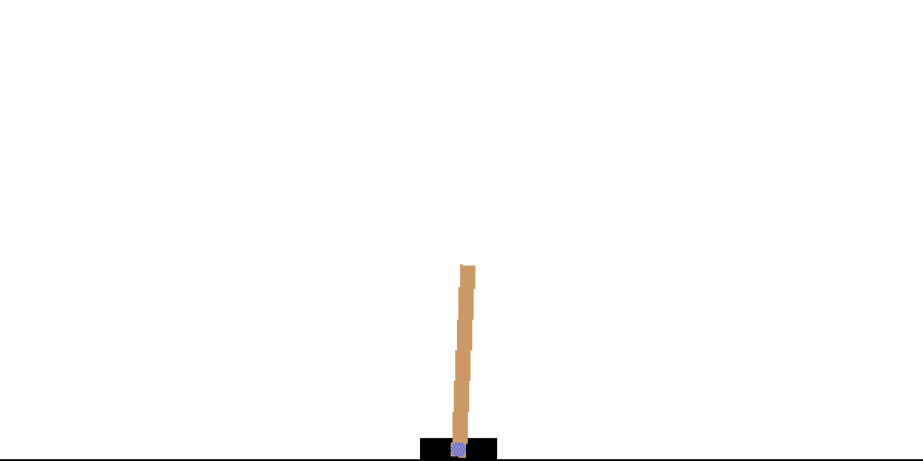
To put this theory into practice, I implemented my own Deep Q-Network in Python. I used the Gymnasium library, developed by OpenAI, which supplies many different reinforcement learning environments. When setting out, I wanted to implement a DQN for an Atari game, such as Space Invaders. However, after starting out, it became apparent that there was a major issue with this. Since Space Invaders is a very complex game with a difficult to uncover strategy, it would take a very long time for the agent to train. For reference, after leaving the program running for almost a week, it had only run 10,000 of the 50,000 repeats of the game I wanted it to attempt during training. Another reason for the computational complexity of this task was the way the agent takes observations of the environment. Rather than the environment supplying values such as the number of enemies, the enemies’ positions, etc, it only supplied a frame of the screen. This meant the frame had to be processed as an array of pixels which takes time to compute and made it harder for the agent to learn from.
Instead of Space Invaders, I made a DQN for the Gymnasium environment “Cart Pole”. This much simpler environment consists of a cart moving along a frictionless track, with a pole balanced on top. A screenshot of the environment is shown in Fig. 10. The goal is to keep the pole balanced on top of the cart for an episode length of 500 steps (where each step consists of the environment taking an input and giving an observation as an output), The agent has 2 possible actions (move the cart left or right) and will receive 4 outputs in the form of an array (the horizontal position of the cart along the track, the cart’s velocity, the angle the pole makes with the vertical and the angular velocity of the pole). The episode terminates when the episode has lasted 500 steps, the pole angle is greater than 12 in either direction or the cart position is greater than 2.4 from the centre (it has hit a wall). The agent receives a reward of +1 for every step taken, meaning it is aiming to take as many steps as possible before the episode terminates (so the maximum cumulative reward is 500).
Fig. 10 A screenshot of the Cart Pole environment
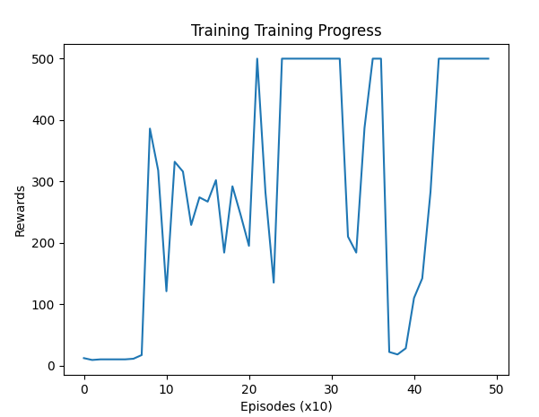
My neural network consisted of 3 hidden layers each with 16 nodes and of course an input layer with 4 nodes and an output layer of 2 nodes. I used the ReLU activation function and the Adam optimizer algorithm to update the weights. The Adam (Adaptive Moment Estimation) optimisation algorithm uses gradient descent but also adjusts the learning rate for each node in the network rather than using a global learning rate. This increases the speed and accuracy of training but also means different learning rates need to be experimented with and tweaked. For all of this, I used the PyTorch library which supplies the building blocks for neural networks. I implemented an epsilon greedy strategy for exploration and used experience replay to evaluate the agent’s policy. I started off by training the agent over 500 episodes, taking a sample of the score every 10 episodes to plot on a graph to track its progress.
Fig. 11 A graph showing the standard training progress of the agent.
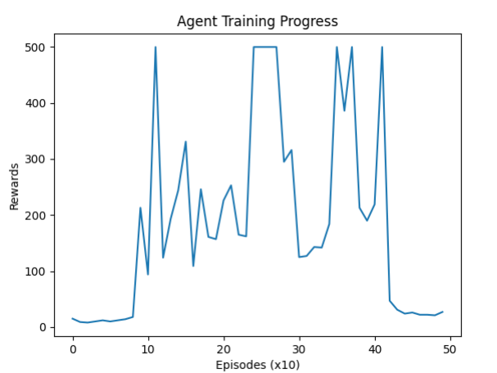
Testing this initial setup, I saw very good results. The graph in Fig. 11 shows how most repeats of the training process looked. The agent takes just less than 100 episodes to start drastically increasing its score. After some variance, it starts to consistently receive the maximum score at some point after 300 episodes. However, since the agent is still partially in its exploration phase, the scores it receives then drops off as it does not fully exploit its successful policy. However, the score will eventually pick back up towards the 500th episode as expected. This does not raise any significant problems apart from a question of whether learning could be terminated after the program starts to consistently receive the maximum reward. However, when visualizing the agent, it seems much more stable when balancing the pole which suggests that it has discovered a better strategy. Whether this matters is up for debate since it receives the maximum score in both cases, but it seems that if the episode were to extend past 500 steps, the second strategy would survive longer. Although, this does become a problem since in around 10% of cases, the agent will have “forgotten” the strategy and not rediscovered it before the 500 episodes of training are complete. This causes the agent to end on a sub-optimal policy (as seen in Fig. 12). This creates a strong case for ending the training earlier when the scores are already at a maximum.
Fig. 12 A case where the agent "forgets" the best strategy.

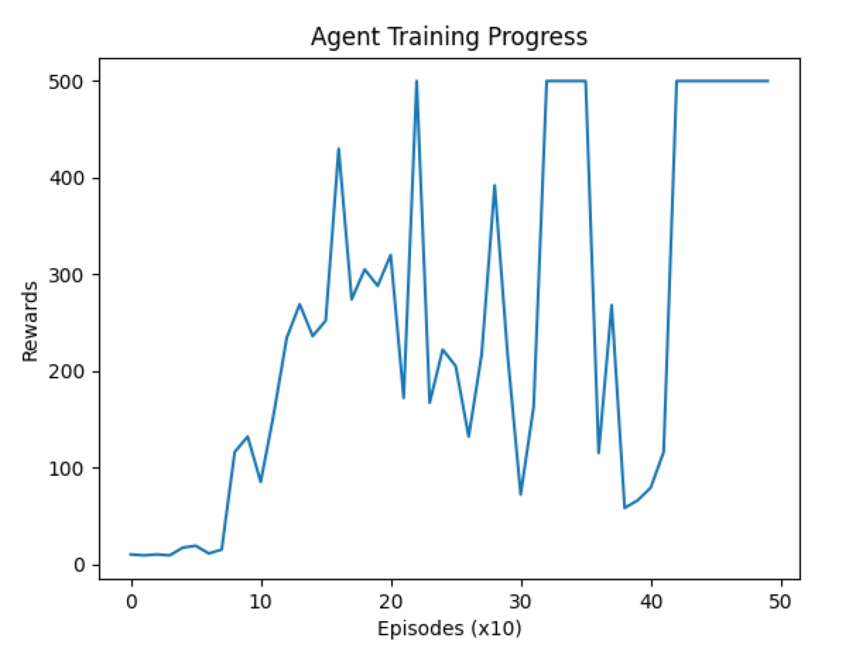
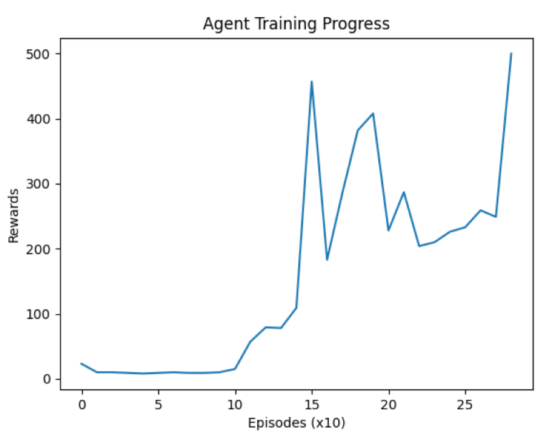

https://www.coursera.org/gb/articles/types-of-machine-learning
https://cs50.harvard.edu/ai/2024/
https://spinningup.openai.com/en/latest/spinningup/rl_intro.html
https://dataheadhunters.com/academy/reinforcement-learning-exploring-policy-vs-value-based-methods/
https://aakash94.github.io/Reward-Based-Epsilon-Decay/
An Introduction to Neural Networks
https://towardsdatascience.com/how-do-we-train-neural-networks-edd985562b73
https://machinelearningmastery.com/rectified-linear-activation-function-for-deep-learning-neural-networks/
learning activation functions to improve deep neural networks
https://www.ibm.com/topics/neural-networks#:~:text=Every%20neural%20network%20consists%20of,own%20associated%20weight%20and%20threshold.
https://medium.com/@sarita_68521/basic-understanding-of-neural-network-structure-eecc8f149a23
https://aws.amazon.com/what-is/overfitting/#:~:text=Overfitting%20occurs%20when%20the%20model,to%20several%20reasons%2C%20such%20as%3A&text=The%20training%20data%20size%20is,all%20possible%20input%20data%20values.
https://towardsdatascience.com/loss-functions-and-their-use-in-neural-networks-a470e703f1e9
https://www.ibm.com/topics/gradient-descent
https://medium.com/@yennhi95zz/4-a-beginners-guide-to-gradient-descent-in-machine-learning-773ba7cd3dfe#:~:text=III.-,Implementing%20Gradient%20Descent,function%20with%20respect%20to%20w.
https://www.geeksforgeeks.org/ml-stochastic-gradient-descent-sgd/
https://medium.com/@eli.hatcher/reinforcement-learning-from-a-to-q-7c1b2f96748
https://medium.com/intro-to-artificial-intelligence/q-learning-a-value-based-reinforcement-learning-algorithm-272706d835cf
https://medium.com/@jereminuerofficial/a-comprehensive-guide-to-deep-q-learning-8aeed632f52f

